Exp. No: 9
Implementation of Magnetic-Field Boundary Conditions between Two Dielectric Media and Determination of Relative Permeability
Test Case (i) – Magnetic Boundary Conditions and Determination of the Relative Permeability
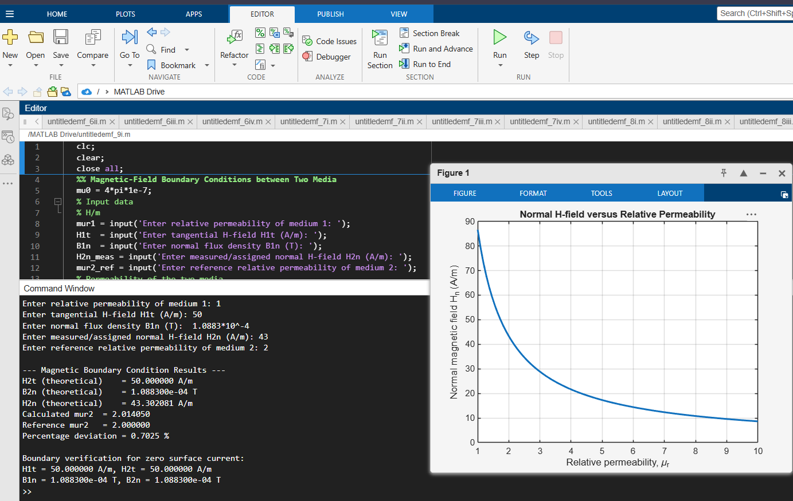
Test Case (ii) – Field Components and Refraction Angle at the Interface of Two Magnetic Media
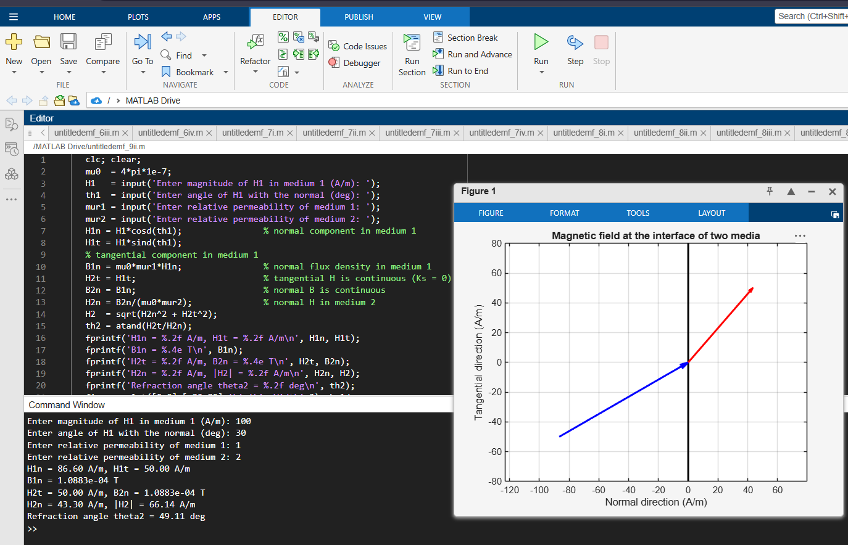
Test Case (iii) – Variation of the Refraction Angle with the Angle of Incidence for Different Permeabilities
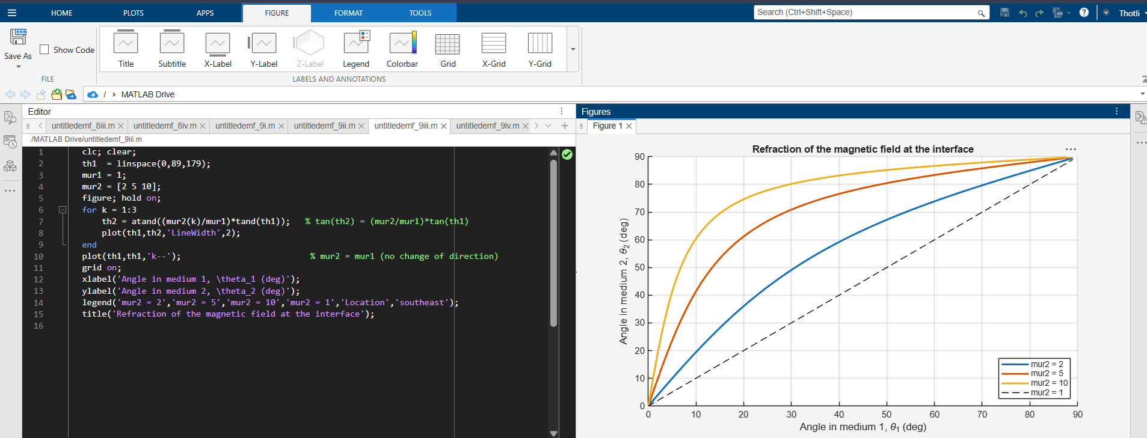
Test Case (iv) – Effect of the Relative Permeability on the Field Components in Medium 2


